**Terna Engineering College**

**Computer Engineering Department**

Program: Sem VII

[**Course: Artificial Intelligence & Soft Computing (AI&SC)**](https://github.com/Amey-Thakur/ARTIFICIAL-INTELLIGENCE-AND-SOFT-COMPUTING-AND-ARTIFICIAL-INTELLIGENCE-AND-SOFT-COMPUTING-LAB)

**Experiment No. 10**

**PART B**

**(PART B: TO BE COMPLETED BY STUDENTS)**

***(Students must submit the soft copy as per the following segments within two hours of the practical. The soft copy must be uploaded on the Blackboard or emailed to the concerned lab in charge faculties at the end of the practical in case there is no Blackboard access available)***

| Roll No. 50 | Name: AMEY THAKUR |
| --- | --- |
| Class: BE-COMPS-50 | Batch: B3 |
| Date of Experiment: 22-10-2021 | Date of Submission: 22-10-2021 |
| Grade : |  |

**B.1 Write down the Title Abstract and Introduction of your research paper on Expert Systems using the Hybrid approach.**

**Title**

Neuro-Fuzzy - Artificial Neural Networks & Fuzzy Logic

**Abstract**

Neuro-Fuzzy is a hybrid system that combines Artificial Neural Networks with Fuzzy Logic. Provides a great deal of freedom when it comes to thinking. This phrase, on the other hand, is frequently used to describe a system that combines both approaches. There are two basic streams of neural network and fuzzy system study. Modelling several elements of the human brain (structure, reasoning, learning, perception, and so on) as well as artificial systems and data: pattern clustering and recognition, function approximation, system parameter estimate, and so on. In general, neural networks and fuzzy logic systems are parameterized nonlinear computing methods for numerical data processing (signals, images, stimuli). These algorithms can be integrated into dedicated hardware or implemented on a general-purpose computer. The network system acquires knowledge through a learning process. Internal parameters are used to store the learned information (weights).

**Introduction**

Fuzzy Logic (FL) is a type of reasoning that is similar to human thinking. This approach is similar to how humans perform decision-making and it involves all other intermediate possibilities between yes and no. For example, suppose there is a question asked as is it raining? In the Boolean logic, the answer can either be yes or no i.e. it only takes the value to be as 1 or 0. But when it comes to fuzzy logic and if we ask the same question, is it raining? we will get different answers like it's very much raining or it's a little rain or very less so we will also get the intermediate possibilities between yes and no [2][3]. The computer won't just take the values 0 & 1. The difference between the Boolean logic and fuzzy logic is that in Boolean we only use the 0 & 1 or the yes and no values but in fuzzy logic, we have intermediate values between this yes and no or 0 & 1. The conventional logic block that a computer understands takes precise input and produces a definite output as true or false which is equivalent to a human saying yes or no. The fuzzy logic was invented by Lotfi Zadeh who observed that unlike computers humans have a different range of possibilities between yes and no.

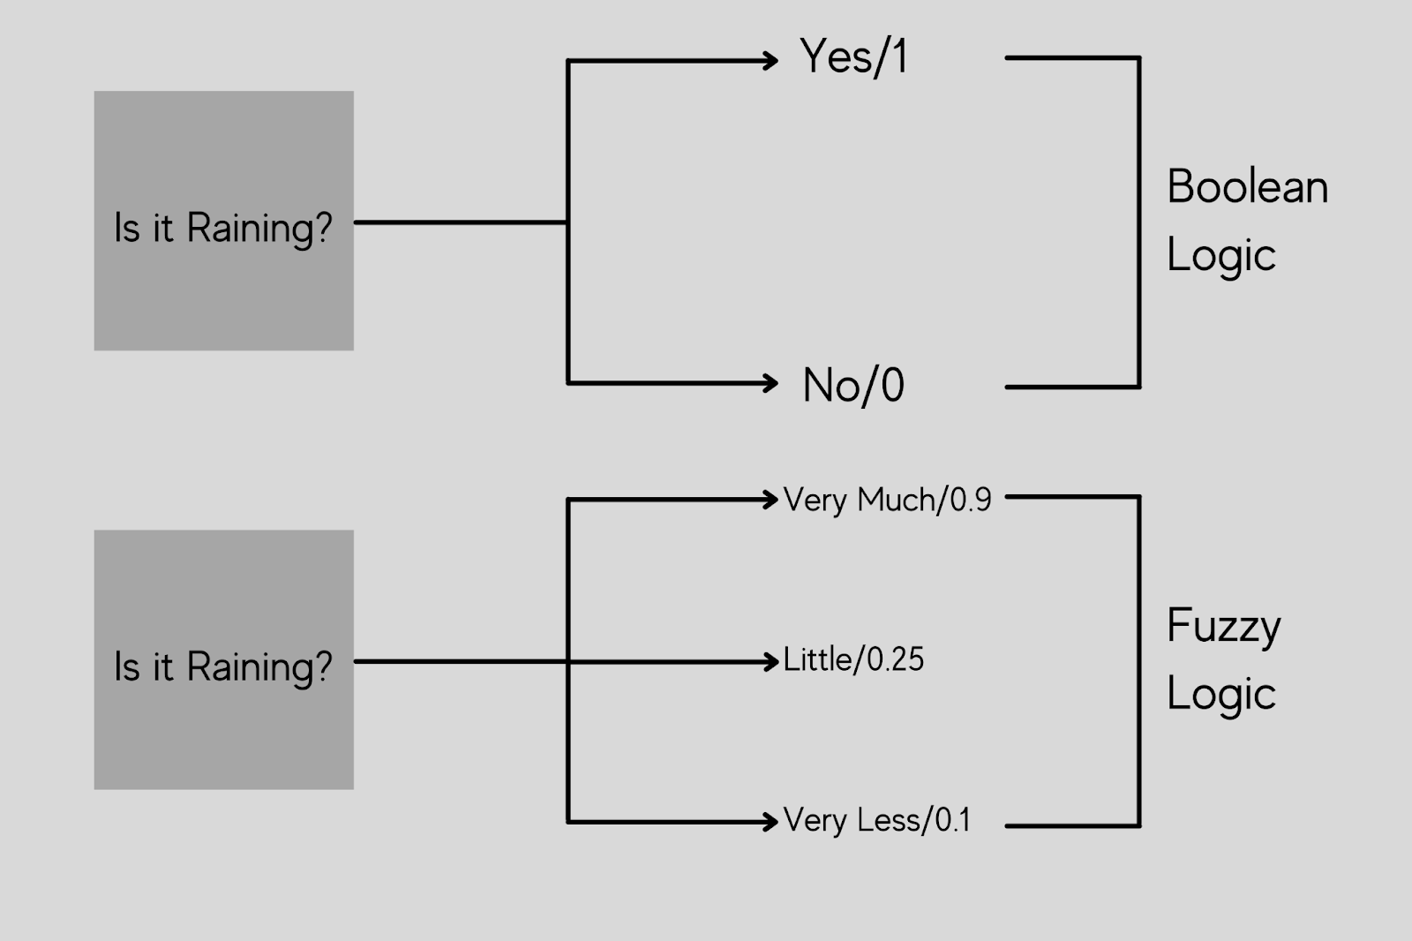

Fuzzy Logic

There can be multiple possibilities such as Certainly Yes, Possibly Yes, Cannot Say, Possibly No or Certainly No. We just do not say only yes or no, we do have certainty or possibilities at times. Fuzzy logic operates on the levels of input possibilities to provide a definitive result. The implementation of this particular logic is it can be implemented in systems with different sizes and capabilities such as microcontrollers, large network or workstation-based systems also this can be implemented in hardware, software, or a hybrid of the two.

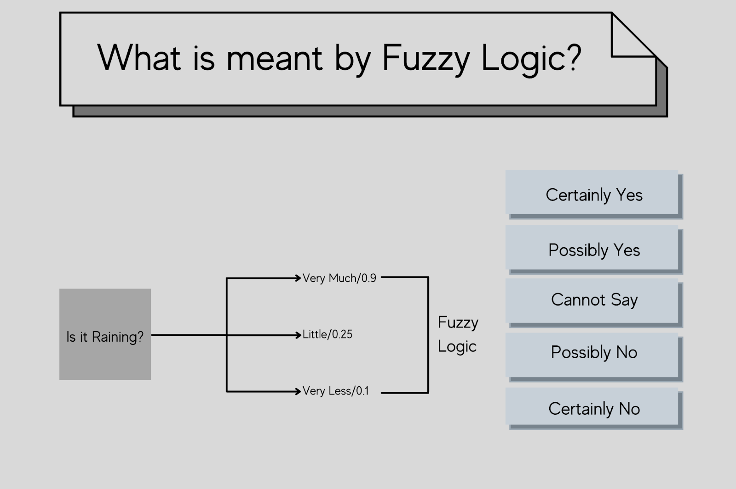

Example of Fuzzy Logic

**B.2 Explain and Draw the proposed methodology framework for expert systems using the hybrid approach for your paper.**

The Fuzzy inference system is a prominent computer framework that is based on fuzzy set theory, fuzzy if-then logic, and fuzzy reasoning. It has been used successfully in fields such as automated control, data classification, decision analysis, expert systems, and computer visualisation. The fuzzy inference system is known by a variety of names due to its multidisciplinary character, including fuzzy-rule-based system, fuzzy expert system, fuzzy model, fuzzy associative memory, fuzzy logic controller, and simply fuzzy system. The aim to use imprecise data in mathematical models resulted in the creation of fuzzy modelling approaches. The tools of fuzzy modelling enable the transformation of a linguistic description into an algorithm, the output of which is an action. Fuzzy logic and fuzzy set theory are the two primary ideas used in fuzzy modelling. Variables in a fuzzy model may represent fuzzy subsets of the universe.

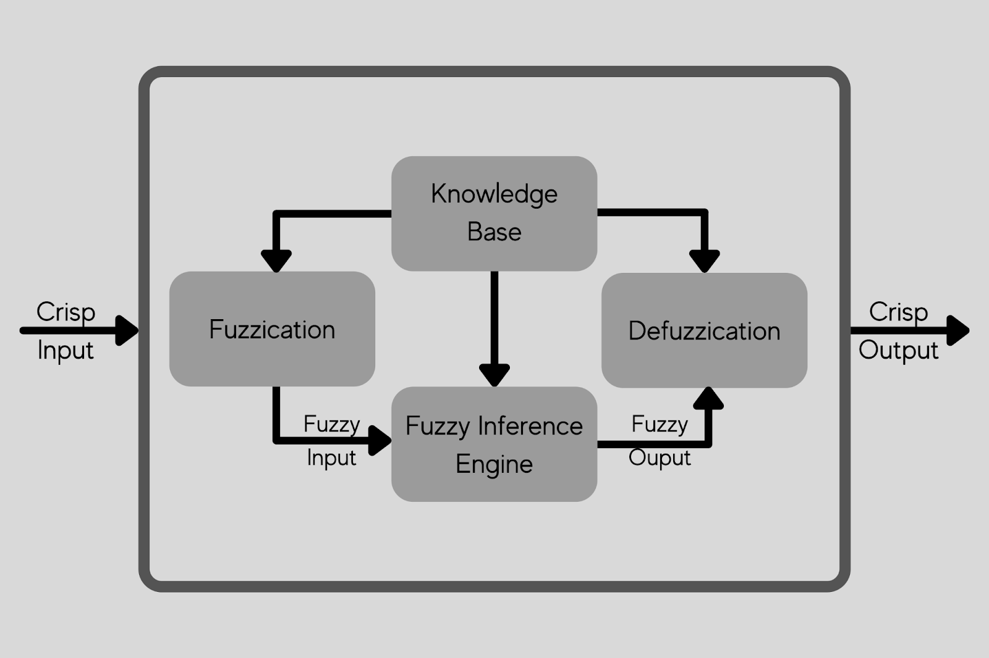

Fuzzy Inference System

As seen in the Figure, a fuzzy inference system (FIS) is made up of four functional components [9].

1. Fuzzification: Converts crisp inputs into degrees of correspondence with linguistic values.
2. Knowledge Base: A knowledge base is made up of a rule base and a database. A rule base is a collection of fuzzy if-then rules. The Membership Functions of the fuzzy sets used in the fuzzy rules are defined in a database.
3. Fuzzy Inference Engine: The inference operations on the rules are performed by the fuzzy inference engine.
4. Defuzzification: Turns the inference's fuzzy results into a crisp output.

Fuzzy inference systems include the Mamdani and Takagi-Sugeno fuzzy systems. A set of language rules acquired from human operators was used to operate a steam engine and boiler combination using the Mamdani fuzzy inference method for the first time.

Takagi and Sugeno were the first to introduce the Takagi-Sugeno fuzzy inference system. The Takagi-Sugeno model differs in that each rule has a distinct output, and the overall output is determined by a weighted average of the outputs of the individual rules.

**Mamdani Fuzzy System**

When implementing the Mamdani rule-based system, which is the most well-known fuzzy system, the following procedure is followed:

1. Fuzzify all input values by converting them to fuzzy membership functions.
2. To compute the fuzzy output functions, run all applicable rules in the rule base.
3. De-fuzzify the fuzzy output routines to get crisp output values.

Fuzzy logic operators: Fuzzy logic operates on membership values in a manner similar to Boolean logic. For that, substitutes for the basic operators AND, OR, and NOT must be offered. There are numerous approaches to this. The Zadeh operators are a popular replacement:

TABLE 1

An Analogy of Boolean & Fuzzy Logic Operators

| **BOOLEAN** | **FUZZY** |
| --- | --- |
| AND (x, y) | MIN (x, y) |
| OR (x, y) | MAX (x, y) |
| NOT (x) | 1 - x |

The fuzzy expressions provide the same result as the Boolean expressions for TRUE/1 and FALSE/0.

IF-THEN rules: IF-THEN rules are used to link input or calculated truth values to desired output truth values.

Example:

1. IF car_speed is very high THEN car_speed is slowed down.
2. IF car_speed is very slow THEN car_speed is increased.

If an output variable appears in several THEN parts, the values from the corresponding IF parts are merged using the OR operator.

**Takagi-Sugeno-Kang (TSK) System**

TSK is identical to Mamdani, except that the defuzzification process is integrated into the fuzzy rule execution. These are also modified such that the rule's consequence is represented by a polynomial function, which is generally constant or linear. The major benefit of adopting TSK over Mamdani is that it is more computationally efficient and works well with other algorithms such as PID control and optimization algorithms. It can also ensure the output surface's continuity. Mamdani, on the other hand, is more intuitive and simpler to deal with. As a result, TSK is typically used in conjunction with more advanced techniques, such as adaptive neuro-fuzzy inference systems.

**B.3 Observations and learning:**

Write down the Advantages of the Proposed system and the disadvantages of the existing system in terms of observation and learning.

**ADVANTAGES AND DISADVANTAGES**

**Advantages of Fuzzy Logic System**

1. The structure of this logic system is very easy and understandable.
2. Fuzzy logic is widely used for commercial and practical purposes.
3. It helps to control machines and consumer products.
4. It helps to deal with uncertainty in engineering.
5. Motley robust as no precise inputs required.
6. If the feedback sensor stops working, one can program it into the situation.
7. It can be easily modified to improve or alter the system performance.
8. Inexpensive sensors can be employed, lowering the total system cost and complexity.

**Disadvantages of Fuzzy Logic System**

1. Fuzzy logic is not always accurate.
2. It cannot recognize machine learning as well as neural network type patterns.
3. Validation and verification of a fuzzy knowledge-based system necessitate significant hardware testing.
4. Setting the exact fuzzy rules and membership functions is a difficult task.
5. At times the fuzzy logic is confused with probability theory.

**B.4 Conclusion and References**

**Fuzzy Logic in brief**

Washing machines that use fuzzy logic are becoming extremely popular. Performance, productivity, simplicity, and productivity are all advantages of these devices. In fact, fuzzy logic is a mathematical notion [8]. It is a mathematical system capable of interpreting and transforming analog input values into logical variables. In basic terms, Fuzzy Logic, in the context of a washing machine, combines sensors to evaluate shifting situations within the machine and adapts its operation correctly. In essence, sensors in the washing machine will supervise the whole washing process, conducting activities based on the various water input, wash interval, rinse performance, and spin speed.

**The Factors to be Considered**

Not all Fuzzy Logic systems are identical, and the parameters sensed in the washing machine are probably different between models. Nevertheless, in general, the dependent factors are frequently kept in mind:

1. The mass of the burden
2. The fabric material
3. The quantity and water temperature
4. The quantity of detergent
5. The filth in the water or rinse must be removed.
6. The kind and duration of agitation necessary
7. The spin cycle's speed and length

**References**

1. Thakur, Amey, and Archit Konde. "Fundamentals of Neural Networks", Volume 9, Issue VIII, International Journal for Research in Applied Science and Engineering Technology (IJRASET) Page No: 407-426. <https://doi.org/10.22214/ijraset.2021.37362>
2. Novák, V.; Perfilieva, I.; Močkoř, J. (1999). Mathematical principles of fuzzy logic. Dordrecht: Kluwer Academic. [ISBN](https://en.wikipedia.org/wiki/ISBN_(identifier)) [978-0-7923-8595-0](https://en.wikipedia.org/wiki/Special:BookSources/978-0-7923-8595-0).
3. Jang, Jyh-Shing Roger, Chuen-Tsai Sun, and Eiji Mizutani. "Neuro-fuzzy and soft computing-a computational approach to learning and machine intelligence [Book Review]." IEEE Transactions on automatic control 42, no. 10 (1997): 1482-1484.
4. ["Fuzzy Logic"](http://plato.stanford.edu/entries/logic-fuzzy/). Stanford Encyclopedia of Philosophy. Bryant University.
5. Zadeh, L.A. (1965). ["Fuzzy sets"](https://doi.org/10.1016%2Fs0019-9958%2865%2990241-x). Information and Control. 8 (3): 338–353. doi:[10.1016/s0019-9958(65)90241-x](https://doi.org/10.1016%2Fs0019-9958%2865%2990241-x)
6. Amey Thakur, Mega Satish."Generative Adversarial Networks", Volume 9, Issue VIII, International Journal for Research in Applied Science and Engineering Technology (IJRASET) Page No: 2307-2325. <https://doi.org/10.22214/ijraset.2021.37723>
7. Zadeh, L. A.; et al. (1996). Fuzzy Sets, Fuzzy Logic, Fuzzy Systems. World Scientific Press. [ISBN](https://en.wikipedia.org/wiki/ISBN_(identifier)) [978-981-02-2421-9](https://en.wikipedia.org/wiki/Special:BookSources/978-981-02-2421-9).
8. Bansod, Nitin A; Kulkarni, Marshall; Patil, S.H. (2005). ["Soft Computing- A Fuzzy Logic Approach"](https://books.google.com/books?id=IkajJC9iGxMC&pg=PA73). In Bharati Vidyapeeth College of Engineering (ed.). Soft Computing. Allied Publishers. p. 73. [ISBN](https://en.wikipedia.org/wiki/ISBN_(identifier)) [978-81-7764-632-0](https://en.wikipedia.org/wiki/Special:BookSources/978-81-7764-632-0).
9. Verma, Karun & Csed, Lecturer. (2021). Use of Fuzzy Set and Neural Network to Extract Fingerprint Minutiae Points and Location.
10. Thakur, Amey, Hasan Rizvi, and Mega Satish. "White-Box Cartoonization Using An Extended GAN Framework." arXiv preprint [arXiv:2107.04551](https://arxiv.org/abs/2107.04551) (2021).
11. Thakur, Amey, Hasan Rizvi, and Mega Satish. "WHITE-BOX CARTOONIZATION USING AN EXTENDED GAN FRAMEWORK.", Volume 5, Issue 12, International Journal of Engineering Applied Sciences and Technology (IJEAST), Page No: 294-298, 2021.
12. Raharja, M. A., I. D. M. B. A. Darmawan, D. P. E. Nila Kusumawati, and I. W. Supriana. "Analysis of membership function in implementation of adaptive neuro fuzzy inference system (ANFIS) method for inflation prediction." In *Journal of Physics: Conference Series*, vol. 1722, no. 1, p. 012005. IOP Publishing, 2021.

**B.5 Question of Curiosity**

1. **Explain performance parameters that will be used to evaluate your proposed system.**

**Ans:**

**Process and Working**

Fuzzy Logic is a method that optimizes your washing machine's performance based on changeable parameters. What does this mean in the actual world? A Fuzzy Logic machine will utilize sensors to assess the level of soiling on your garments. This is accomplished by the use of optical sensors that measure the clarity of the water after the tub has been filled. More dirt or grease will decrease the clarity of the water. This allows the machine to compute saturation, which determines how much detergent and water are needed for a clean wash. It will also decide the time and direction of spin, among other things, to ensure that your clothing is as efficient as possible.

## **MEMBERSHIP FUNCTION**

The membership function is a graph [12] that defines how each point in the input space is mapped to membership value between 0 & 1. It allows us to quantify linguistic terms and represents a fuzzy set graphically [5][7]. A membership function for a fuzzy set A on the universe of discourse X is defined as μA: X which implies to [0,1].

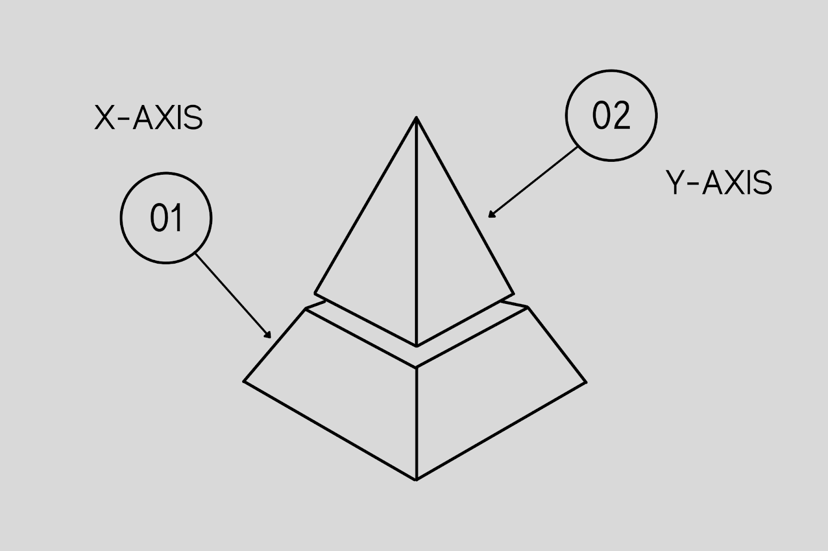

Membership Function

This quantifies the degree of membership of the element in X to the fuzzy set A and the X-AXIS represents the universe of discourse whereas the Y-AXIS represents the degrees of membership in the [0,1] interval. There can be multiple membership functions applicable to falsify a numerical value. Simple membership functions are used as the complex functions that do not add precision in the output. Membership functions characterize fuzziness (i.e., all the information in a fuzzy set), whether the elements in fuzzy sets are discrete or continuous. Membership functions are represented by graphical forms. Rules for defining fuzziness are fuzzy too.

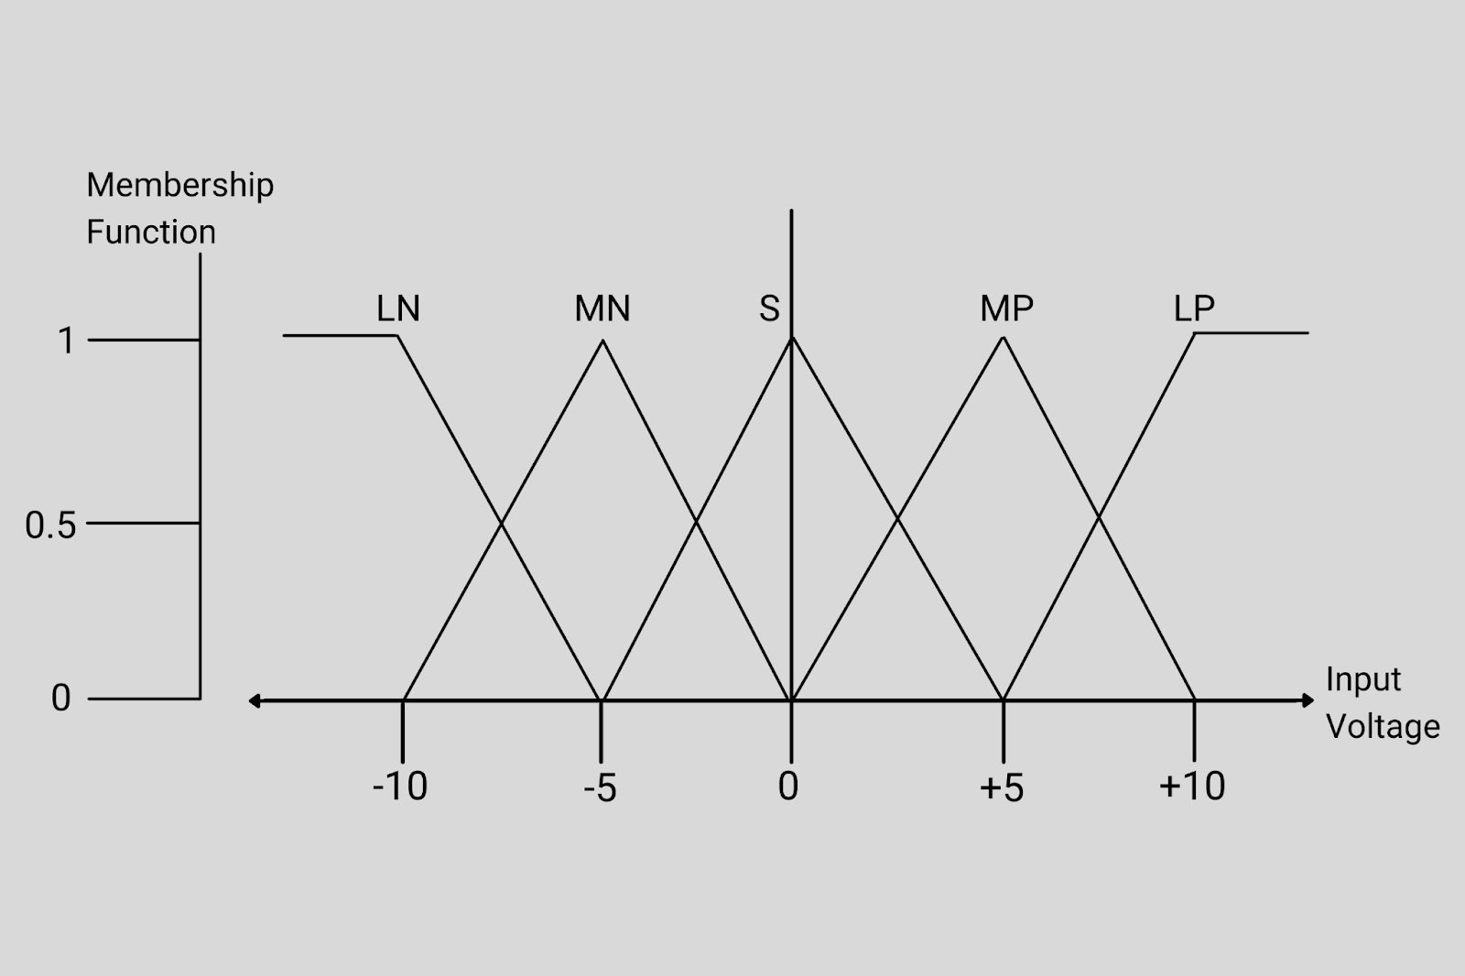

Membership Functions for LP, MP, S, MN and LN.

Membership functions for LP, MP, S, MN and LN. For the X and y-axis, we have the membership functions and input voltage. The triangular membership function shapes are most common among various other membership function shapes. The input to the 5 level fuzzifier varies from -10 volts to +10 volts. Hence the corresponding output also changes. Based on these volts the value for the membership function will also change as we can see in the graph where from -10 to +10 volt there has been a great variation in the graph of input voltage and membership function.